Automated Watering System (AWS)

Project Objective:

A Senior Design Project ECE 396-397 where groups of 3-4 are to design and create a project with a 250$ budget, main objective for our group was to develop an automated watering system for the Plant Research Lab at UIC.

Using an Arduino BT controller, various sensors, actuators, also information from outside weather situation. The microcontroller will make appropriate decisions in whether it should water the provided plants or not water them.

Project Design:

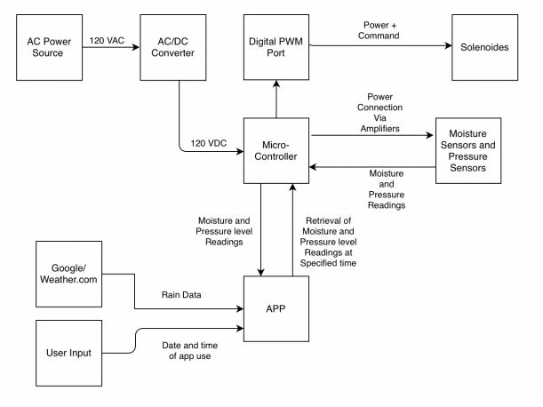Overall, there are two parts for the project, a Circuit Design, and a Software Design.

Figure 1:Block Diagram of Project

Circuit Design:

We are receiving 120VAC power from the inside of the greenhouse. The power will then travel to an AC-DC converter to convert the voltage to 120VDC. The current then goes through two resistors. The 115kΩ resistor leads to the V+ pin on the Arduino BT. The 5kΩ resistor leads to ground. There are four linear solenoids connected to the Digital PWM ports of the Arduino BT, each solenoid on a separate pin. There are four soil moisture sensors connected to the Analog inputs of the Arduino BT. The soil moisture sensors connect to the pins of the Arduino through amplifiers.

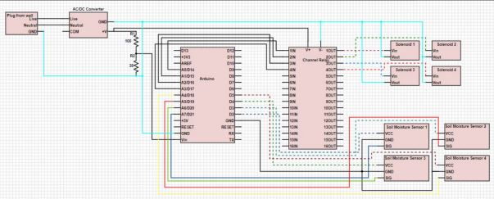

Figure 2: Electrical Schematic of System

Software Design:

The software design is split up into two separate sections, app design and microcontroller design. Priority for the design is for a controlled and accurate decision making, with efficiency in mind.

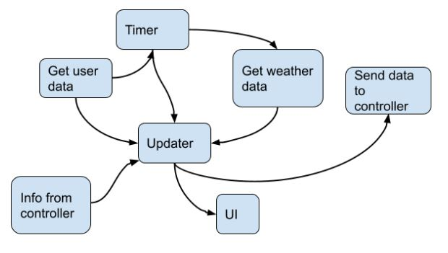Software Design for App:

The app will regularly check the weather data from an external source. The app will also show the user the current weather, which solenoids are open or closed also allowing the user to open or close any/all solenoids if they so choose to and provide the user with the current moister from each moister sensor.

Figure 3:Software Design for App

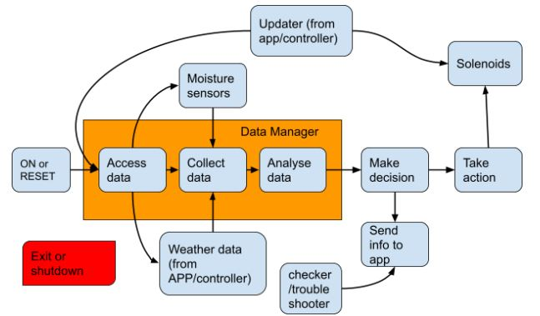Software Design for Microcontroller:

Figure 4:Software Design for Microcontroller

The microcontroller being a Arduino Nano 33 IoT, having both Bluetooth and Wi-Fi capabilities. We got the Arduino to connect to the app with Bluetooth to get info regarding the weather.

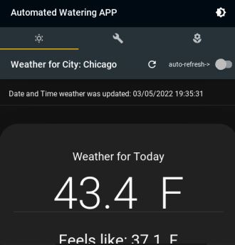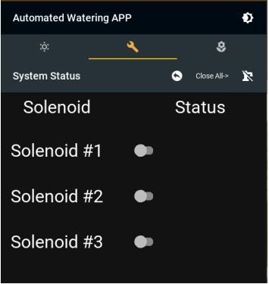And receive info from the user if necessary. The Arduino will also send information regarding the current moister levels and which solenoids are currently open and giving water to which plant.

Figure 5:App Demonstration

Figure 6:App Solenoid System

Figure 7: App weather options

Warning notifications where also prepared, if necessary, in the case the plants that where being water were outside during cold temperatures. In this case the plants were inside a more controlled environment.

Figure 8: Test warning notification

Equipment & Devices Used:

In completion of the project the parts used whereas followed:

4 ½” 12VDC Plastic Solenoid Valve

1 16 Channel 12V relay module

Note: a smaller relay module would have been used but there was a lack of supply

1 Arduino Nano 33 IoT with headers

1 AC/DC Converter 12V 65W

4 SEN-13637 (moisture sensors)

Vinyl tubing, Pvc tubing and connectors.

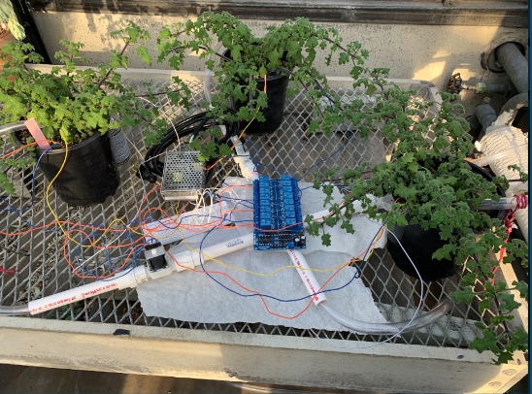

Figure 9: Senior Design final project TEST RUN

Equipment Cost:

With the entire expenses of the equipment the total cost of the project ends up reaching $208.13,

This left us with $41.87 left over.